**DFA to Program Tutorial**

The following example will help you convert a simple DFA to an equivalent computer program.

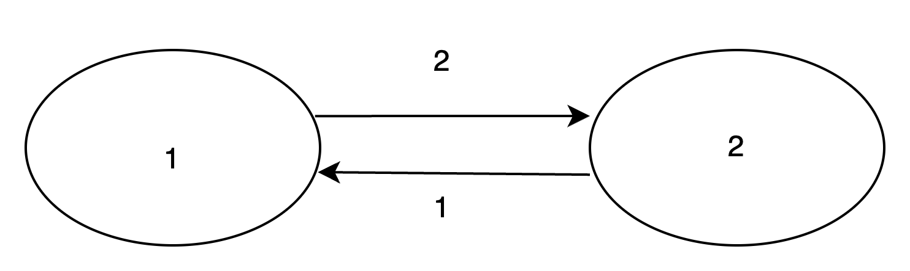

To store the state of a DFA, a variable (memory space) named *state* may be used. The program should also make use of a variable called *input* to take the input of the machine. After taking the values of both *state* and *input* variables as input from the user, the program should use a series of if statements to change the value of the state variable to the desired value as per the DFA. For example, if the value of state is 1 and the value of input is 2, then based on the above DFA the value of state variable should be changed to 2 using an if statement. On the other hand, if the value of state is 2 and the value of input is 1, then the value of the state variable should be changed to 1 using another if statement.

The complete C++ program that is equivalent to the above DFA is given below:

#include <iostream>

using namespace std;

int main()

{

int dfa_current_input, dfa_current_state;

cin>>dfa_current_state;

cin>>dfa_current_input;

if(dfa_current_state==1 && dfa_current_input==2){

dfa_current_state=2;

cout<<"Current State : "<<dfa_current_state;

}

if(dfa_current_state==2 && dfa_current_input==1){

dfa_current_state=1;

cout<<"Current State : "<<dfa_current_state;

}

return 0;

}